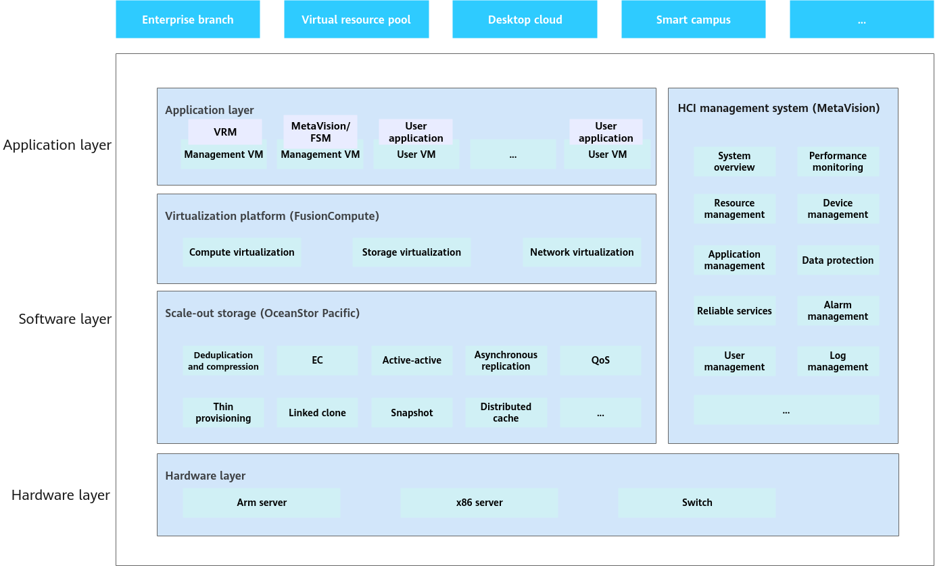

MetaVision
Huawei's MetaVision is a management software for its FusionCube Hyper-Converged Infrastructure (HCI), which simplifies the deployment, management, and scaling of IT resources. It provides a unified interface for managing compute, storage, and network resources in a single system, enabling one-click initialization, scaling, and operations and maintenance (O&M). Key features include simplified management, high performance, and data protection capabilities like ransomware protection.

Concept | Description
FusionStorage Manager (FSM) | Management process of scale-out storage software.
FusionStorage Agent (FSA) | Management agent process of scale-out storage software to implement communication between nodes and FSM.
Database (DB) | Service process of a database.
Virtualization resource management (VRM) | FusionCompute management process.
User virtual machine (VM) | User VM of FusionCompute.
UltraVR | Disaster recovery (DR) software, which implements unified DR management for FusionCompute VMs.
Kernel-based virtual machine (KVM) | A KVM enables multiple user VMs to run on a host.
vSwitch | Virtual switch, which implements network communication between VMs.
MetaVision | Original name: FusionCube Vision (FCV for short), which is HCI management software.
Management computing node agent (MCNA) | A node that provides management and compute functions or management, compute, and storage functions.  NOTE:  FusionCube supports two deployment modes: hyper-converged infrastructure (HCI) and disaggregated hyper-converged infrastructure (dHCI). In HCI deployment mode, MCNA provides management, compute, and storage functions. In dHCI deployment mode, MCNA provides only management and compute functions.
Storage computing node agent (SCNA) | A node that provides storage and compute functions.
Computing node agent (CNA) | A node that provides compute functions.
Database node (DBN) | A node that provides database functions.
Storage node agent (SNA) | A node that provides storage functions.

Networking
In FusionCompute scenarios, FusionCube supports two node configuration modes: HCI and dHCI. Table 1 describes deployment rules.
Table 1 Deployment rule
Deployment Scenario | Node Type | Node Description | Deployment Rule
HCI | MCNA | Management computing node agent with storage functions, which contains components such as MetaVision, FSM, KVM, and FSA. | Two such nodes must be deployed.
HCI | SCNA | Storage computing node agent, which contains components such as KVM, FSA, and user VMs. | Zero or more such nodes must be deployed.
HCI | CNA | Computing node agent, which contains components such as KVM, FSA, and user VMs. | Zero or more such nodes must be deployed.
HCI | DBN | Database node, which contains the FSA and DB components. | Zero or more such nodes must be deployed.
dHCI | MCNA | Management computing node agent without storage functions, which contains components such as MetaVision, FSM, KVM, and FSA. | Two such nodes must be deployed.
dHCI | SNA | Storage node agent, which contains the FSA component. | At least three such nodes must be deployed.
dHCI | CNA | Computing node agent, which contains components such as KVM, FSA, and user VMs. | Zero or more such nodes must be deployed.
dHCI | DBN | Database node, which contains the FSA and DB components. | Zero or more such nodes must be deployed.

Access port
Purpose: Connects end-user devices like PCs, printers, and cameras to the network.
VLANs: Supports only a single VLAN.
Tagging: Removes VLAN tags from incoming traffic and adds the appropriate tag for outgoing traffic, ensuring the end device only sees untagged traffic.
Trunk port
Purpose: Connects switches to other switches or to devices like wireless access points that need to support multiple VLANs.
VLANs: Carries multiple VLANs simultaneously.
Tagging: Uses a tagging protocol like 802.1Q to label each frame with its VLAN ID, so downstream devices know which VLAN the traffic belongs to.
Hybrid port
Purpose: Provides a flexible solution for connecting devices that may need to belong to different VLANs or when a single port must carry both tagged and untagged traffic.
VLANs: Can support multiple VLANs.
Tagging: Can be configured to handle both tagged traffic (like a trunk) and untagged traffic (like an access port) on the same port. This is ideal for scenarios where a VoIP phone and a PC are connected to the same port, with the phone handling voice (tagged) and the PC handling data (untagged).

• Hybrid ports can carry both tagged and untagged VLANs.
• You can define:
- PVID (Port VLAN ID) → The default VLAN for untagged frames.
- Tagged VLANs → VLANs that will be sent with 802.1Q tags.
- Untagged VLANs → VLANs that will be sent without tags.

port link-type hybrid → Hybrid mode enabled.
port hybrid pvid vlan 1032 → Untagged frames arriving will be assigned to VLAN 1032.
port hybrid tagged vlan 1033 → VLAN 1033 frames will be sent tagged.
port hybrid untagged vlan 1032 → VLAN 1032 frames will be sent untagged.
This means:

Server sees backup VLAN (1032) as untagged.
Server sees heartbeat VLAN (1033) as tagged.

• The switch reads the 802.1Q VLAN tag in the frame.
• If the VLAN ID in the tag is not in the allowed VLAN list for that port:
- Frame is dropped (discarded).
• If the VLAN ID is valid and allowed:
- Frame is forwarded to the correct VLAN.

Eg for trunk
interface Eth-Trunk10
description Uplink-to-Core
port link-type trunk
port trunk allow-pass vlan 3 352 to 354 1031 to 1034
stp edged-port disable
mode lacp-dynamic

Eg for access and hybrid
#
interface Eth-Trunk15
description Svr4-Bkup(N)
port link-type hybrid
port hybrid pvid vlan 1035
port hybrid tagged vlan 1036
port hybrid untagged vlan 1035
stp edged-port enable
mode lacp-dynamic
dfs-group 1 m-lag 15
#
interface Eth-Trunk17
description Bkup1-Bkup(P)
port link-type access
port default vlan 1032
stp edged-port enable
dfs-group 1 m-lag 18
#

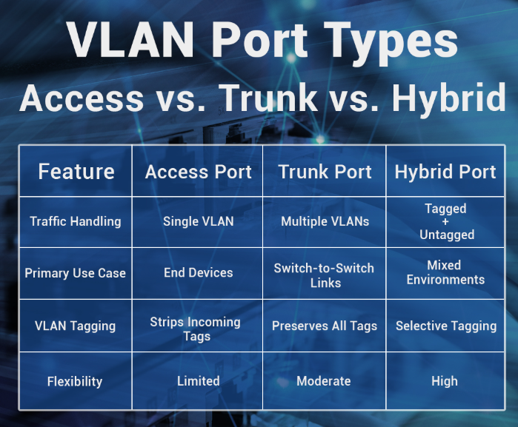

Hybrid port can handle more than 2 VLAN destinations

interface Eth-Trunk11
port link-type hybrid
port hybrid pvid vlan 1032
port hybrid untagged vlan 1032
port hybrid tagged vlan 1033 1034 1035

Figure 1 Networking (HCI deployment mode)
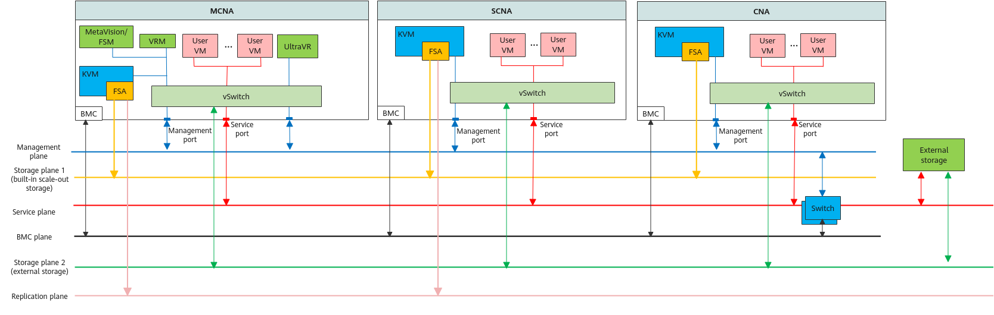

Figure 2 Networking (dHCI deployment mode)
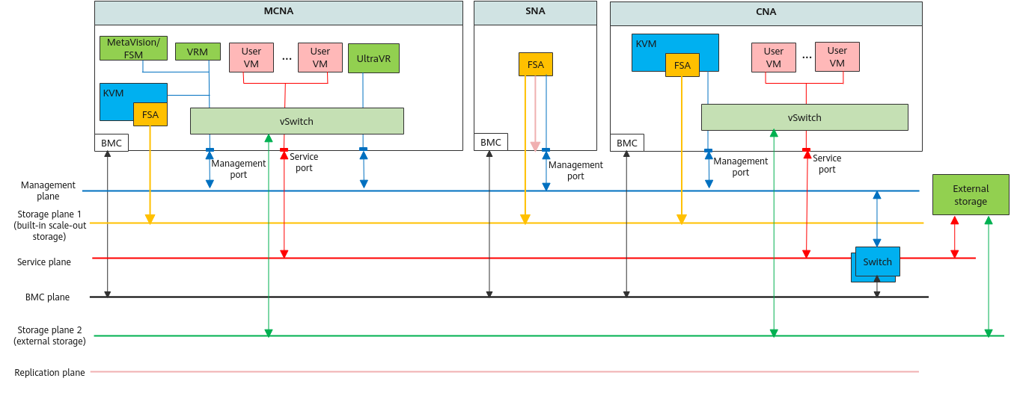

PROD

 | IP Address | Default gateway | VLAN
Management IP | 192.168.89.54/27 | 192.168.89.33 | 354
Management IP | 192.168.89.55/27 | 192.168.89.33 | 354
Backup IP | 172.16.2.11/24 | 172.16.2.1 | 1032
Backup IP | 172.16.2.12/24 | 172.16.2.1 | 1032
Replication IP | 172.16.4.13/24 | 172.16.4.1 | 1034
Replication IP | 172.16.4.14/24 | 172.16.4.1 | 1034

Non-PROD

 | IP Address | Default gateway | VLAN
Management IP | 192.168.89.52/27 | 192.168.89.33 | 354
Management IP | 192.168.89.53/27 | 192.168.89.33 | 354
Backup IP | 172.16.5.11/24 | 172.16.5.1 | 1035
Backup IP | 172.16.5.12/24 | 172.16.5.1 | 1035
Replication IP | 172.16.4.11/24 | 172.16.4.1 | 1034
Replication IP | 172.16.4.12/24 | 172.16.4.1 | 1034

 |  | For Backup Purpose (10Gbps)
 |  | For Replication Purpose (10Gbps)
 |  | For Management Purpose (1Gbps)
SFP+ |  |  |  |  |  |  |  |  |  |  |  |  |  |  |  | QSFP28
1 | 3 |  | 5 | 7 | 9 | 11 | 13 | 15 |  | 17 | 19 | 21 | 23 | 25 | 27 | 1 | 3 | 5
Svr1-Data | Svr3-Data |  | Svr1-HCI | Svr3-HCI | Svr1-Bkup(P) | Svr3-Bkup(P) | Svr4-Data | Svr4-Bkup(N) |  | Bkup1-Bkup(P) | Bkup2-Bkup(N) | Svr1-Mgt | Bkup1-Mgt1 |  |  |  |  | DAC
Svr2-Data | Reserved |  | Svr2-HCI | Reserved | Svr2-Bkup(P) | Reserved | Reserved | Reserved |  | Bkup1-Airgap | Bkup2-Airgap | Svr2-Mgt | Bkup2-Mgt1 |  | Uplink |  |  | DAC
2 | 4 |  | 6 | 2 | 4 | 6 | 14 | 16 |  | 18 | 20 | 22 | 24 | 26 | 28 | 2 | 4 | 6
SFP+ |  |  |  |  |  |  |  |  |  |  |  |  |  |  |  | QSFP28
SFP+ |  |  |  |  |  |  |  |  |  |  |  |  |  |  |  | QSFP28
1 | 3 |  | 5 | 1 | 3 | 5 | 13 | 15 |  | 17 | 19 | 21 | 23 | 25 | 27 | 1 | 3 | 5
Svr1-Data | Svr3-Data |  | Svr1-HCI | Svr3-HCI | Svr1-Bkup(P) | Svr3-Bkup(P) | Svr4-Data | Svr4-Bkup(N) |  | Bkup1-Bkup(P) | Bkup2-Bkup(N) | Svr3-Mgt | Bkup1-Mgt2 |  |  |  |  | DAC
Svr2-Data | Reserved |  | Svr2-HCI | Reserved | Svr2-Bkup(P) | Reserved | Reserved | Reserved |  | Bkup1-Airgap | Bkup2-Airgap | Svr4-Mgt | Bkup2-Mgt2 |  | Uplink |  |  | DAC
2 | 4 |  | 6 | 8 | 10 | 12 | 14 | 16 |  | 18 | 20 | 22 | 24 | 26 | 28 | 2 | 4 | 6
SFP+ |  |  |  |  |  |  |  |  |  |  |  |  |  |  |  | QSFP28

IP information for setup Huawei Ocean Protect
OceanProtect X3000

PROD Network switch port connectivity
Swich port 9,10,11 are connected to Huawei FusionCube Server (Backup network),
Switch Port 17 are connected to Ocean Protect (PROD) Backup network
Port 18 is connected for replication network,
Port 23 for PROD Management Plane for CEXUATDC1TL01

Non-PROD Network switch port connectivity
Swich port 13 are connected to Huawei FusionCompute Server (Backup network),
Switch Port 19 are connected to Ocean Protect (PROD) Backup network
Port 20 is connected for replication network,
Port 24 for Non-PROD Management Plane for CEXUATDC1TL02

Ocean protect
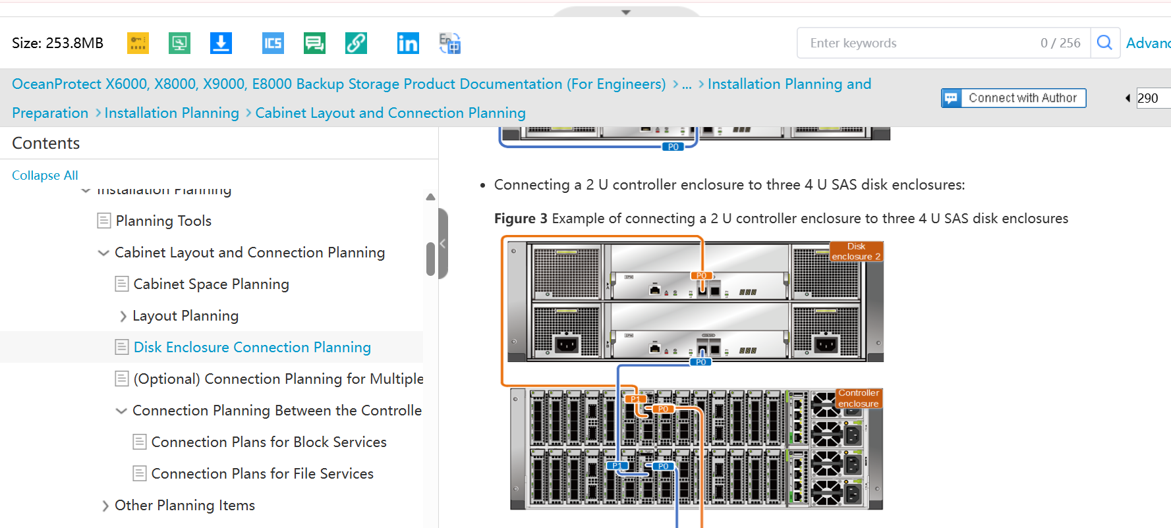
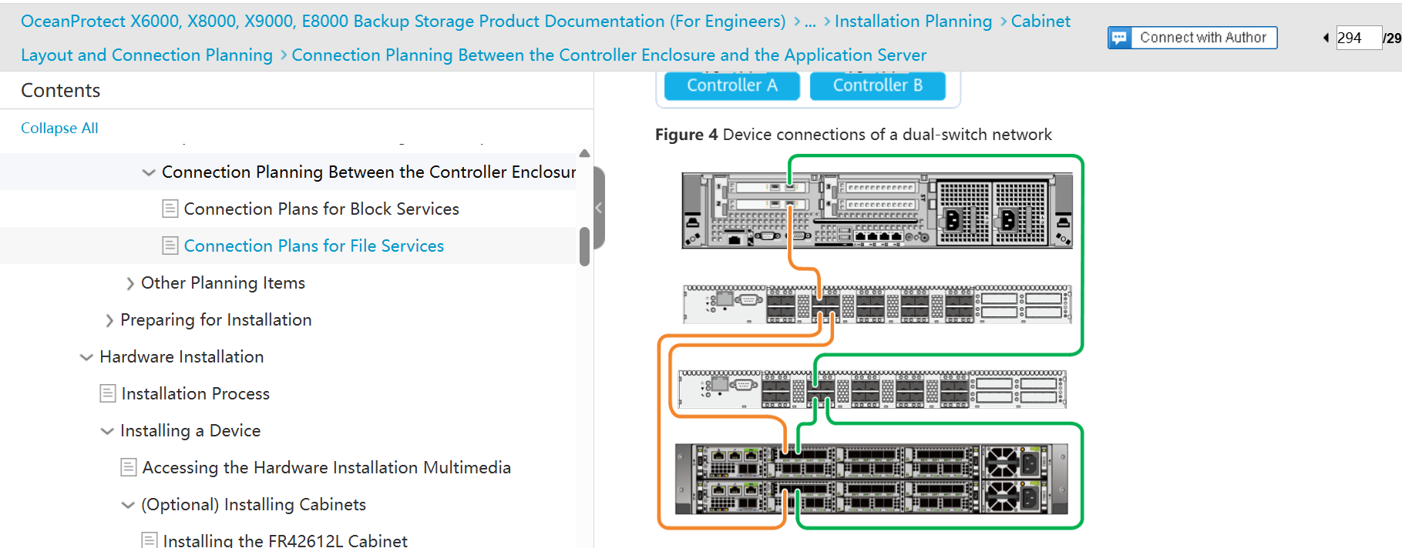
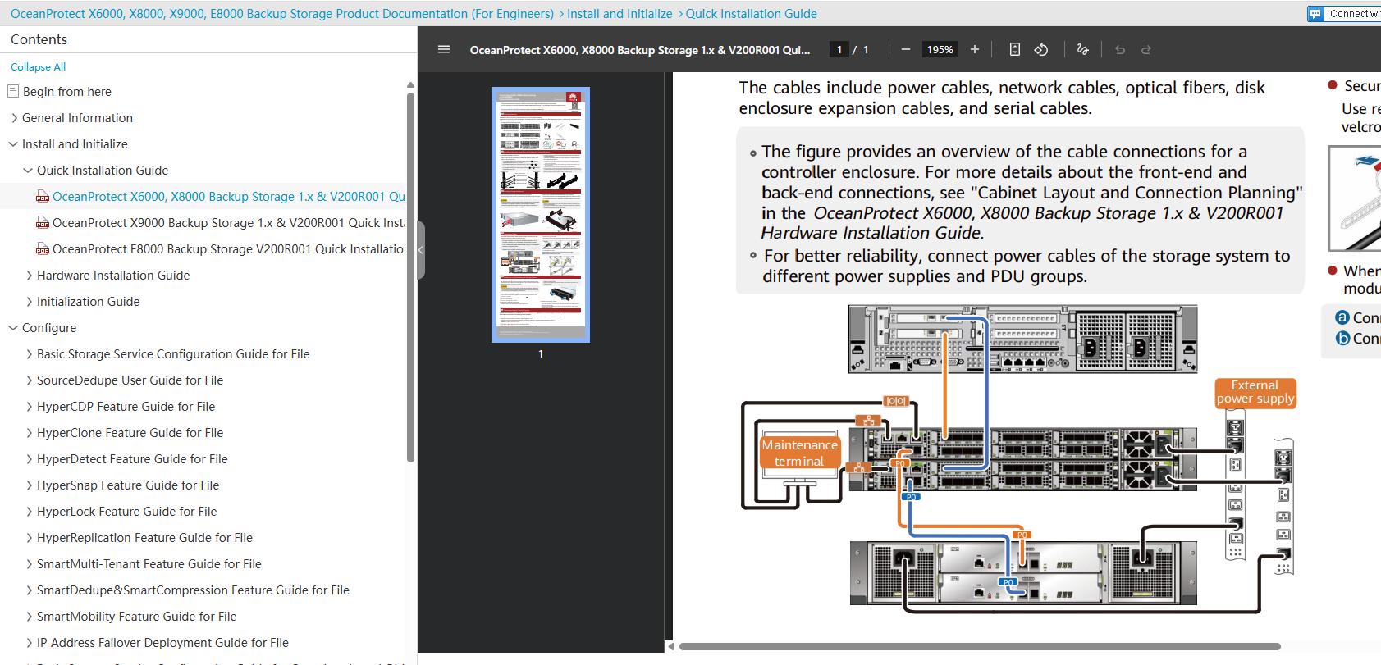

Changing IP Addresses of Management Network Ports Using DeviceManager
If the maintenance terminal has been connected to a management network port of the storage device and the IP address of the maintenance terminal and the default IP address of the management network port are in the same network segment, you can log in to DeviceManager using the default IP address of the management network port to change its IP address. If you have changed IP addresses of management network ports using a serial port, skip this section.
Prerequisites
The maintenance terminal has been connected to a management network port of the storage device, and the IP address of the maintenance terminal and the default IP address of the management network port are in the same network segment.
Context
For a 2 U controller enclosure, the default IP addresses of the management network ports on controllers A and B are 192.168.128.101 and 192.168.128.102, respectively, and the default subnet mask is 255.255.0.0.
For a 4 U controller enclosure, the default IP addresses of management network port 0 on management modules 0 and 1 are 192.168.128.101 and 192.168.128.102, respectively, and the default subnet mask is 255.255.0.0.
Precautions

Glossary
A
Active Directory (AD) | A directory service for Windows Standard Server, Windows Enterprise Server, and Windows Datacenter Server.
Application-oriented VM | A VM created for implementing an application. It is different from a desktop cloud VM. An application-oriented VM runs specific server software, such as SQL Server, to implement specific functions.
Asynchronous replication | A remote replication technique. When data at the primary site is updated, the data does not need to be updated synchronously to the mirroring site to finish the update. In this way, performance is not reduced due to data mirroring.
B
Bare VM | It is also called an empty VM. A VM that is assigned an identity but does not occupy any CPU, memory, storage, or network resource in the system.
Baseboard Management Controller (BMC) | A dedicated micro controller embedded in the main board of a computer (especially a server).
BIOS | Basic Input/Output System.  It is a piece of firmware stored on the computer motherboard. It contains basic input/output control programs, power-on self-test (POST) programs, bootstraps, and system setting information. The BIOS provides hardware setting and control functions for the computer.
C
Configuration Management Database (CMDB) | A database that stores and manages device configuration information in an enterprise IT system. The CMDB provides data required for service processing and provisioning. It also works with other components to ensure data accuracy.
Computing Node Agent (CNA) | An agent deployed on a compute node and used to manage the VMs and VM mounting on the compute node.
Converged deployment of storage and compute resources | Compute and storage resources are deployed on the same node.
Cluster | A computer technology that integrates a set of loosely connected servers to work together so that in many respects they can be viewed as a single system. A cluster is used to improve system stability, reliability, data processing capability, and service capability. For example, a cluster is used to reduce single-point failures, share storage resources, load balances, and improve system performance.
Control cluster | Composed of control nodes of a Scale-Out Storage system.
Cluster Manager | A cluster management process, which is used to manage the status of the entire storage cluster.
Cluster authentication | Used for authenticating remote devices.
Cluster Configuration Database (CCDB) | A database of a Scale-Out Storage system, which stores configuration information of a cluster.
Control Virtual Machine (CVM) | CVM stands for Control Virtual Machine.
Copy | Redundancy provided for data or services in a scale-out storage system. Data copies of the same data are stored on different nodes. If data stored on a node is lost, the same data can be read from the copies.
Customer Relationship Management (CRM) | CRM is a technology used to manage interactions with customers and potential customers. A CRM system helps organizations build customer relationships and streamline processes so they can increase sales, improve customer service, and increase profitability.
Container | An operating system virtualization form that packages and isolates applications and their entire runtime environment (including all required files).
Certificate Signing Request (CSR) | CSR stands for Certificate Signing Request.
Complex Programmable Logic Device (CPLD) | CPLD is used to implement various operations and combinational logic.
D
Data Center (DC) | A data center consists of one or more zones. In a broad sense, a DC is a collection of data center resources without definite resource boundaries in a region. The zone, however, has definite resource boundaries.
Dynamic Power Management (DPM) | A module that intelligently powers on or off idle physical servers based on the system load on the network.
Dynamic Resource Scheduler (DRS) | A module that uses intelligent scheduling algorithms to flexibly schedule resources and dynamically balance system load to improve user experience.
Distributed Virtual Switch Management (DVSM) | A module used to manage distributed virtual switches (DVSs). Deployed in the same cluster with the Virtual Resource Management (VRM) node, the DVSM creates, deletes, maintains, and presents DVSs in the system. Each cluster has a DVSM module.
Database Node (DBN) | Database nodes of the FusionCube system.
Data synchronization | Synchronization refers to a process of synchronizing differential data between a local volume and a remote volume.
Data rebuilding | A process of restoring data saved on a faulty member disk.
Data Dump | A mechanism of dumping the data in a system to another system or medium, and deleting the dumped data from the original system.
Deduplication | A data compression technology specially used to eliminate coarse-grained redundant data. In the deduplication process, duplicate data is deleted, leaving only one copy of the data to be stored, along with a link to the unique copy of data. Deduplication is able to reduce the required storage capacity since only one copy of data is stored.
E
Elastic Virtual Switch (EVS) | A virtual switch that implements data switching, virtual local area network (VLAN) isolation, Dynamic Host Configuration Protocol (DHCP) isolation, bandwidth limiting, and priority setting.
Equipment Serial Number (ESN) | This uniquely identifies a set of equipment.
EC | Erasure Coding
EC | A storage mode in which 1.x data copies are stored to achieve low data redundancy but high data reliability. Data is divided into data fragments of a fixed length. Based on the EC algorithm, every M continuous data fragments are calculated to generate N parity fragments. The value of N is smaller than that of M.
Enterprise Resource Planning (ERP) | ERP refers to a type of software that organizations use to manage day-to-day business activities such as accounting, procurement, project management, risk management, regulatory compliance, and supply chain operations.
F
Full Clone | A complete and independent copy of a VM. A full clone can have independent system disks and different software from the parent VM. Full clones apply to common office automation scenarios.
FusionCube Builder | A tool used to install and configure FusionCube quickly at site.
FusionStorage Agent (FSA) | A management agent process of a system. It is deployed on each management, storage, and compute node to implement communication between the nodes and FusionStorage Manager (FSM).
FusionStorage Manager (FSM) | A system management process. You are advised to deploy FSM on two management nodes in active/standby mode.
Floating IP address | An IP address used by a two-node cluster to communicate with external systems. The active and standby nodes have an IP address each. For example, the active node uses IP address 1, and the standby node uses IP address 2. During communication with an external client, another IP address (for example, IP address 3) is used. IP address 3 is bound to the NIC of the active node (the active node has two IP addresses 1 and 3). The external client communicates with the active node which has IP address 3. The standby node has only IP address 2 and does not provide services externally. When an active/standby switchover occurs, IP address 3 is released from the original active node and bound to the NIC of the new active node (original standby node). That is why the IP address is called a floating IP address.
FC SAN | A type of storage area network (SAN) that uses fiber channels between servers and storage devices. FC SAN devices provide high performance but are expensive, and are gradually replaced by IP SAN devices.
FusionCompute | Used for virtualizing physical resources and providing VMs. It consists of the Virtual Resource Management (VRM) and host software.
G
Graphics Processing Unit (GPU) | A specialized electronic circuit designed to accelerate the building of three dimensional and special-effect images. A GPU works for a video card as a CPU works for a computer.
Guest OS | An OS running on a VM. Guest OSs running on multiple VMs of a host can be different.
H
Host | A physical server that runs virtualization software. VMs can be created on a host.
Hypervisor | A software layer on a virtualized server. It is used to manage the virtual machines (VMs) on the virtualized server and help VMs share hardware resources of the server. The KVM hypervisor is the basic abstraction layer of software that sits directly on the hardware below any operating systems. It is responsible for CPU scheduling and memory partitioning of the various VMs running on the hardware device. The hypervisor not only abstracts the hardware for the VMs but also controls the execution of VMs as they share the common processing environment. The KVM Hypervisor does not process networks, storage devices, videos, or other I/O resources.
HA | High Availability
HA | A method of implementing a specified function through active and standby modules working in hot backup mode to improve the reliability. When the active module is faulty, the standby module automatically becomes the new active module to implement the function.
HyperMetro | A value-added active-active storage feature that enables data sets of two storage systems to provide storage services as one data set, achieving load balancing and failover without interruption.
Heartbeat | Heartbeat is a packet that does not need to be responded between two devices. It is used to report that the device works normally. Heartbeat supports node communication, fault diagnosis, and event triggering in high-availability software.
I
Internet Small Computer Systems Interface (iSCSI) | A transport protocol that provides for the SCSI protocol to be carried over a TCP-based IP network.
IP SAN | A type of storage area network (SAN) that uses IP channels instead of optical fibers to connect servers and storage devices. The use of IP SAN devices is not restricted by transmission distances. IP SAN device performance is not as good as the FC SAN device performance, but with the increase of the IP bandwidth capability, the performance of IP SAN devices is gradually improved.
InfiniBand (IB) | A computer network communication standard used in high-performance computing, which features very high throughput and very low latency.
K
Kubernetes (K8s) | An open-source system used to automatically deploy, scale, and manage containerized applications. It aims to provide a platform for automatic deployment, expansion, and running of application containers across host clusters.
Kernel-based Virtual Machine (KVM) | An open-source virtualization technology built in Linux. Specifically, KVM helps users turn Linux into a hypervisor that enables a host computer to run multiple isolated virtual environments, that is, virtual clients or VMs.
L
Linked Clone | A duplicate of a VM that uses the same base disk as the parent VM and a chain of delta disks to keep track of the differences between the original and the clone. The linked clone technology reduces the need for disk space and increases the maintenance efficiency. Linked clones apply to scenarios that require VMs using the same software installation, for example, call centers. System disks on linked clones can have slight differences from the system disk on the parent VM. The differences are stored on delta disks of the linked clones.
Linked Cloning | A technology that creates a snapshot on a parent VM, generates a copy for the snapshot, and creates other VMs on the copy.
Linked Snapshot | A snapshot taken only for the memory or storage changes of a VM. A VM can be restored using multiple relevant linked snapshots. A snapshot can be taken for the memory or storage resource.
Live Migration | Also known as hot migration, this is a method of migrating virtual machines (VMs) without interrupting services.
Local Storage | Storage space provided by a local computing node agent (CNA).
Logical Cluster | A logical group consisting of servers with the same attributes, such as CPU, storage, and distributed virtual switch (DVS), in a physical cluster. The VM HA function takes effect only for servers in the same logical cluster.
LUN | Logical Unit Number (LUN)
Logical Volume Manager (LVM) | A mechanism for managing disk partitions in Linux.
M
Management Computing Node Agent (MCNA) | A host providing computing and management functions. An MCNA not only provides services, but also hosts management VMs of FusionCube, including the VRM and FusionStorage Manager.
Multi-copy | A protection technology that stores data copies on multiple nodes to ensure data reliability.
MetaVision | The system management center of FusionCube. It provides system initialization (only when the device is powered on for the first time), system resource management, alarm monitoring, performance monitoring, and O&M management.
Multichassis Link Aggregation Group (M-LAG) | A mechanism that implements link aggregation among multiple devices. In an active-active system, one device is connected to two devices through M-LAG to achieve device-level link reliability.
N
Network Attached Storage (NAS) | A storage device that provides shared disk space on the network. It functions as file sharing on a Windows system or the Network File System (NFS) on a Linux system.
Network Interface Card (NIC) | It is named ethN in the virtualization system. N indicates a digit.
Network Time Protocol (NTP) | An application-layer protocol which uses IP and UDP to synchronize the time between the distributed time server and the client. NTP is evolved from Time Protocol and ICMP Timestamp Message and features high protocol accuracy and good health.
NAS | A storage device that provides shared disk space on the network. It functions as file sharing on a Windows system or the Network File System (NFS) on a Linux system.
Network File System (NFS) | A UNIX presentation layer protocol developed by SUN, allowing users to access files stored on a remote computer as if they accessed the files on the local computer.
O
Open Virtualization Format (OVF) | A standard released by the Distributed Management Task Force (DMTF) for setting up a standard and portable metadata model which enables VMs to be deployed on different virtualization platforms.
Open Virtual Appliance (OVA) | A VM packaging format that allows VM templates to be allocated, customized, and instantiated in any open virtualization format that supports VM management.
P
Port Group | A group of ports with the same attributes on a distributed virtual switch (DVS) or virtual software switch (VSS). In a hypervisor, all DVS settings, such as virtual local area network (VLAN) and network flow control, are configured on a port group basis.
Pre-boot Execution Environment (PXE) | This technology enables computers to boot from the network. This technology is the successor of Remote Initial Program Load (RPL). The PXE works in client/server mode. The PXE client resides in the ROM of a network card. When the computer boots up, the BIOS invokes the PXE client to the memory. The PXE client obtains an IP address from the DHCP server and downloads the operating system from the remote server through TFTP.
Q
Quality of Service (QoS) | A service that allows virtual storage device to migrate from one physical storage node to another without interrupting the VM running. With the QoS enabled, users can control the resources in a better way with costs reduced and a higher customer satisfaction.
Quorum server | A server that provides arbitration services for clusters or HyperMetro to prevent the resource access conflicts of multiple application servers.
Quorum Server Mode | This mode applies to scenarios where a third-party quorum server is available. In this mode, an independent physical server or a VM is used as the quorum server. You are advised to deploy a quorum server at a third-place site. In this way, when a disaster occurs in a single data center, the quorum server still works.
Quorum network | This network enables communication between the quorum server and sites.
R
Resource Cluster (RC) | A cluster that allocates VMs within a zone. Each resource cluster maps a cluster object in the hypervisor. Generally, a resource cluster consists of resources that have the same attributes, such as model, host object, resource definition, and resource management policy. Resource clusters can have different quality of service (QoS).
Replication cluster | Composed of replication nodes in a Scale-Out Storage system.
Replication node | A server where replication software runs.
Replication control cluster | Composed of replication control nodes in a Scale-Out Storage system.
Replication network | This network enables data transmission between sites.
Replication service cluster | A cluster that provides replication pairs and consistency groups, as well as communication between sites.
Remote Direct Memory Access over Converged Ethernet (RoCE) | A network protocol that allows remote direct memory access (RDMA) over Ethernet. Currently, there are RoCE v1 and RoCE v2. RoCE v1 is a data link layer protocol that allows communication between any two hosts in the same Ethernet broadcast domain. RoCE v2 is a network layer protocol and its packets can be routed.
Recovery Point Objective (RPO) | RPO indicates the maximum tolerable data loss amount of a service system.
Recovery Time Objective (RTO) | RTO refers to the target time taken to resume the disrupted key services to an acceptable level and is set to minimize impact of a disruption on the services.
Remote replication | A core technology for disaster recovery and backup, which is also a foundation for remote data synchronization and disaster recovery. This technology remotely maintains a set of data mirrors using the remote data connection function of the storage devices located in different places. Even when a disaster occurs, the data backup on the remote storage device is not affected.
S
Storage Area Network (SAN) | A dedicated network used to provide and manage storage devices for enterprises and telecom carriers.
Software Client (SC) | Software running on a common PC to process the virtual desktop protocol.
Service Catalog | List of services that an organization provides to its employees or customers. On the service catalog configuration page of the FusionManager, users can create, deploy, compile, and delete applications.
Site | A group of servers at the same physical location.
Snapshot | A reproduction of the memory or storage data on a VM created at a specific time point. Snapshots can be used to restore VMs to a state when these snapshots were taken.
Single Sign On (SSO) | A property of access control over multiple related but independent software systems. With this property, a user logs in once and gains access to all systems without being prompted to log in again at each of them. This is a popular solution for enterprise service integration.
Self-Service Provisioning (SSP) | A service provided by the FusionManager to allow tenants to use system functions.
Storage Cold Migration | A storage migration mode that allows data migration on a volume only after all VMs on the volume are stopped.
Storage Resource Pool | A collection of storage resources. For example, an IP storage area network (IP SAN) functions as a storage resource pool for a cluster.
Storage Thin Provisioning | Storage thin provisioning is the act of using virtualization technology to give the appearance of more physical storage resources than is actually available. It allows storage space to be easily allocated to users on an on-demand and auto-scale basis. This optimizes utilization of available storage resources.
Storage Computing Node Agent (SCNA) | A host providing storage and computing functions.
Storage Node Agent (SNA) | A storage node in the FusionCube system
Storage cluster | A cluster formed by the system storage nodes.
Separate deployment of storage and compute resources | Compute and storage resources are deployed on different nodes.
Static Priority Mode | This mode applies to scenarios where no third-party quorum server is available.
SSH | Secure Shell  The SSH protocol is used to ensure secure system management and file transfer on insecure networks. It uses encryption to protect the connection between the client and the server. All user authentication, commands, output, and file transfer are encrypted to prevent attacks on the network.
SSL | Secure Sockets Layer
SSL | A security protocol that works at a socket layer. This layer exists between the TCP layer and the application layer to encrypt or decode data and authenticate concerned entities.
SMTP | Simple Mail Transfer Protocol
SMTP | A TCP/IP protocol that is used to send e-mails. This protocol specifies how two systems interwork with each other and defines the format of messages to be sent.
SNMP | Simple Network Management Protocol
SNMP | A network management protocol of TCP/IP. This protocol allows remote users to view and modify network element management information. This protocol ensures transmission of management information between any two points. The polling mechanism is adopted to provide basic function sets. According to SNMP, both hardware and software agents can monitor the activities of various devices on a network and report these activities to a network console workstation. The control information about each device is maintained by using a management information block.
Simple Service Discovery Protocol (SSDP) | An application-layer protocol, which is one of key protocols that implement Universal Plug and Play (UPnP).
Synchronous replication | A mode in which data is synchronously replicated from the active node to the standby node, which ensures both performance and data consistency.
Small Computer System Interface (SCSI) | A basic protocol for interconnection and communication between a host and external devices.
Stack | Stack refers to connecting more than one switches together to provide as many ports as possible within limited space. Multiple switches are stacked to form a stacking unit.
Structured Query Language (SQL) | A database query and programming language widely used for accessing, querying, updating, and managing data in a relational database. It consists of data definition language (DDL), data manipulation language (DML), and data control language (DCL).
SAN | A dedicated network used to provide and manage storage devices for enterprises and telecom carriers.
Service-Level Agreement (SLA) | An agreement signed between a service provider and a customer on service reliability. It is a commitment to the service level.
T
Thin Client (TC) | A terminal with lower processing power than a Thick Client that processes the virtual desktop protocol, serves as the client of the remote desktop, and provides an access method for users.
Thin Pool | A thin pool is implemented based on storage thin provisioning. It allows storage space to be dynamically allocated to users on demand. This optimizes utilization of available storage resources.
Thin LUN | A thin LUN is a logical storage unit created in the thin pool. The thin LUN is accessible to the host.
Tools | Tools is a virtualized driver for VMs. Tools improves VM performance, enables VM hardware monitoring and advanced VM functions, such as migration, snapshot taking, and on-line CPU adjustment.
Transmission Control Protocol (TCP) | The protocol within TCP/IP, which is used to break up data messages into packets to be sent using Internet Protocol (IP), verify packets received through IP, and reassemble them into complete information. A connection-oriented, reliable protocol (reliable in the sense of ensuring error-free delivery). TCP corresponds to the transport layer in the ISO/OSI reference model.
Transport Layer Security (TLS) | Used to provide confidentiality and data integrity between two communication applications. TLS consists of TLS Record and TLS Handshake.
U
User Datagram Protocol (UDP) | A standard TCP/IP protocol that allows an application program on one end to send datagrams to an application program on the other end. UDP uses the IP to deliver datagrams, providing applications with unreliable connectionless packet delivery services.
V
Virtual Application (vApp) | A collection of VMs running in a virtual data center (VDC). VMs belonging to a vApp are dependent on each other. A vApp ensures that VMs in it meet the preset sequence and time requirements when they are started or stopped in a VDC.
Virtual CPU (vCPU) | A hyper-thread on a server with multiple physical CPUs, which have multiple physical cores on each CPU and multiple hyper-threads on each core.
Virtual Switch (VDS) | A switch created on a physical server by using virtualization software. A virtual switch enables communication between VMs that are on the same or different physical servers.
Virtual Firewall (vFW) | A network firewall service or appliance running in a virtualized environment to provide the usual packet filtering and monitoring functions like a physical network firewall.
Virtual Disk | A file in the host file system. For a customer operating system, it functions as a physical disk drive. The file can be configured on the host or a remote file system. After configuring a VM with a virtual disk, you can install a new operating system to the disk file without having to repartition a physical disk or restart the host.
Virtual Machine Hibernate | An operation that can be performed on a running VM. After the hibernated VM is started, it restores all programs before the hibernation.
Virtual Machine IP Address | The IP address assigned to a VM, corresponding to the IP address of a physical machine. The VM can communicate with other devices on the network through the IP address.
Virtual Memory | Virtualized memory for a VM allocated based on the physical memory. Even if the memory is not physically contiguous, it is contiguous for the VM. The VM can randomly save and obtain data in its virtual memory without affecting the memory accessibility of other VMs on the same physical machine.
Virtual Network Card | A network card for VMs that corresponds to that of a physical machine. Multiple virtual network cards can be created for a single VM. The virtual network card can connect to the physical network card in bridge mode for data transmission.
Virtual Server | This is where the operating system and applications run based on various virtualization technologies, unlike the original physical server. When using certain resources of the physical server, the virtual server is the same as the physical server for users. Both partitions and VMs are considered virtual servers.
Virtual Local Area Network (VLAN) | An end-to-end logical network across different network segments and networks, constructed using the network management software based on the switching LAN. Network resources and users are logically divided based on a certain principle and a physical LAN is logically divided into multiple broadcasting domains (VLANs). The hosts on a VLAN can directly communicate with each other whereas different VLANs cannot. This efficiently suppresses broadcasting packets.
Virtual Machine (VM) | One or multiple computer systems virtualized from a physical server.
Virtual Machine Dispatch (VMD) | A function that controls the scheduling policy configuration and the control points of the policy dispatching.
VM High Availability | With this, the O&M system continuously monitors all physical hosts and automatically migrates all VMs off a faulty host.
VM Migration | A technology used to migrate VMs to another hardware resource for VM operations.
VM Specifications | A set of pre-defined VM attributes for creating VMs with unified specifications.
VM Template | A template used to create VMs that have the same specifications. A template is a VM in essence. After a VM is converted to a VM template, only its isTemplate attribute is changed to true.
Volume | The logical storage volume of a VM, which can either be system volume or user volume.
Virtual Resource Management (VRM) | Virtualization management software, which comprises infrastructure products together with the Unified Virtualization Platform (UVP).
Virtual Software Switch (VSS) | This is deployed on a computing node and performs the virtual network switching function for the VMs on the node.
Virtual Block Service | A service I/O process of a Scale-Out Storage system. VBS manages volume metadata, provides the Scale-Out Storage access point service through SCSI or iSCSI interfaces, and enables application servers to access Scale-Out Storage resources.
Virtual Desktop Infrastructure (VDI) | Virtual desktop device. It uses the server virtualization technology to virtualize hardware resources of servers into logical resource pools, create VMs on demand, and deliver VMs to end users through a desktop protocol.
Virtual Network Console (VNC) | An open-source software based on UNIX and Linux OSs. It provides powerful remote management capabilities. An auxiliary desktop login method used when desktop login fails due to network faults of the desktop operating system.
Z
Zone | The largest resource group in a data center (DC). A zone consists of all logical resources within an independent layer 2 network in the service plane in the DC, such as hosts, datastores, subnet pools, elastic IP address pools, virtual firewalls, and virtual load balancers. A zone has independent virtual local area networks (VLANs) and uplink ports. Zones are separated from each other at layer 2 and therefore can use the same VLAN.

